Alarm: (ID 34) Alarm Block Battery Low

This alarm is triggered when the battery block is lowered.
figure
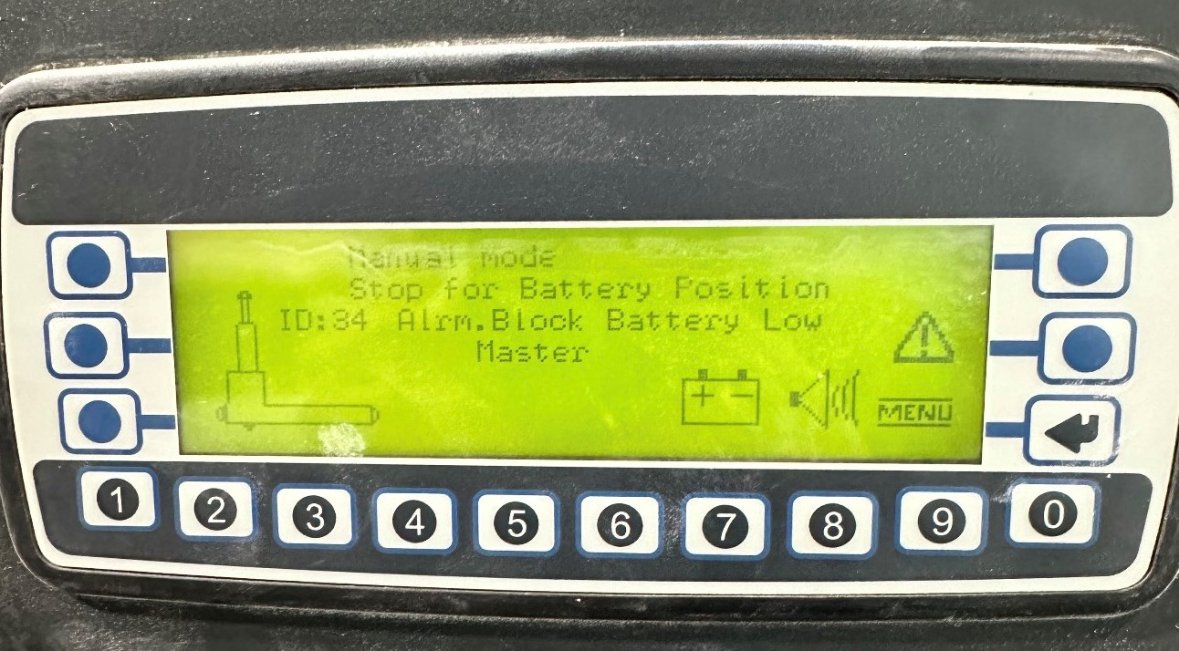
How To Fix:
To resolve the issue:
- Raise the battery block by pressing the Up/Down button on the front of the AGV.

